ASSESSMENT - 14 | PYTHON - 07

*“FILE HANDLING : READ & WRITE IN CSV FILE”*



Submitted By

VAIBHAV PATIDAR

IPS ACADEMY, INDORE (M.P.)

**Date :** 19-12-2023 | **Day 14**

**Week 3** | **Day - 02**

**FILE HANDLING IN PYTHON :**

* File handling is a process of dealing with files containing data.
* We can read, write update the content of a file using python language, modules and libraries,

**CSV FILES :**

* Full form of CSV is “Comma Separated Values”.
* In this type of files data is stored in tabular form.
* Data is stored in CSV file for better readability, easy understanding and faster processing.

**Different Methods to Read a CSV File in Python :**

1. Read CSV file using csv.reader
2. Read CSV file using .readlines() function
3. Read CSV file using Pandas
4. Read CSV file using csv.DictReader

**→ Writing program to read a CSV File using csv.reader() :**

**>First, printing the headers of the CSV file:**

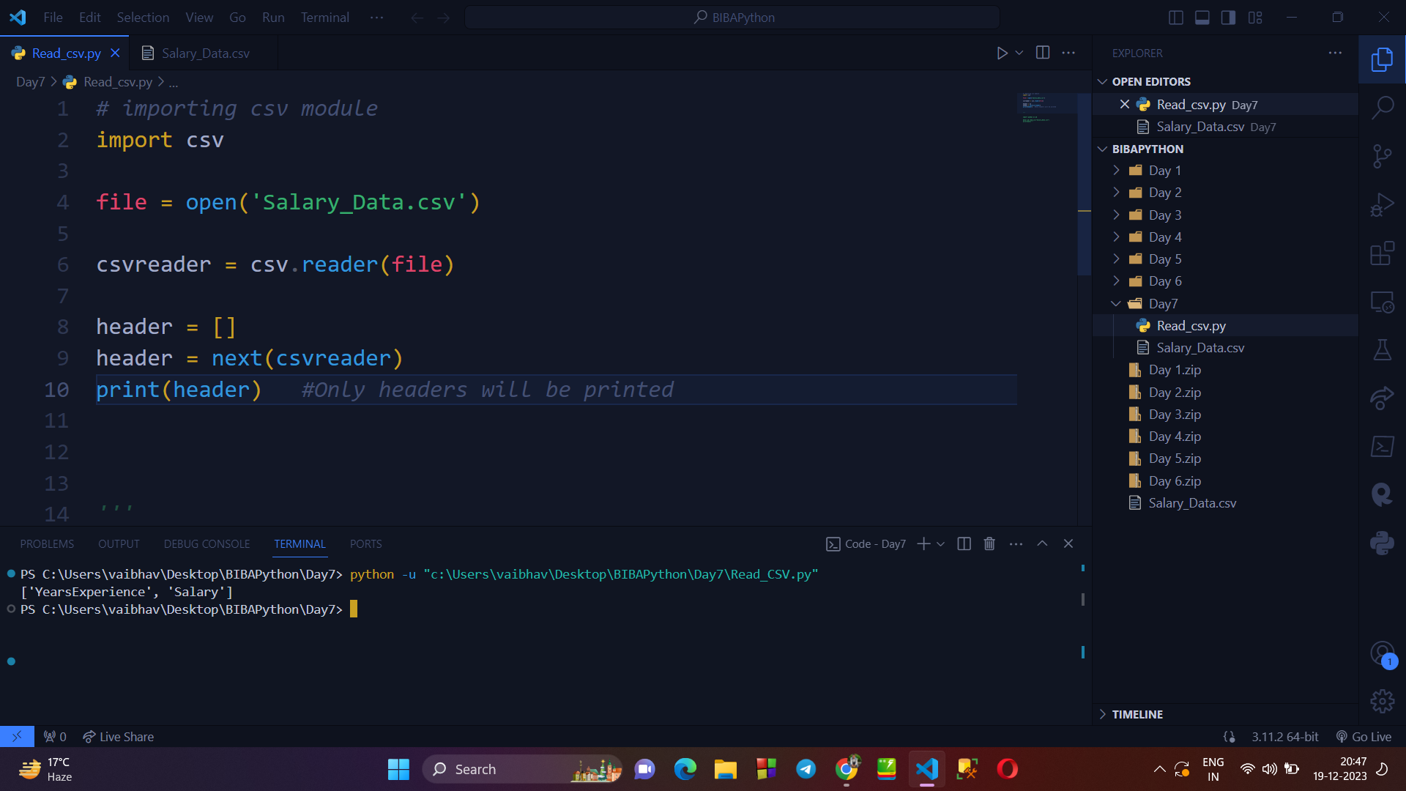

**>Printing the rows / content of the csv file :**

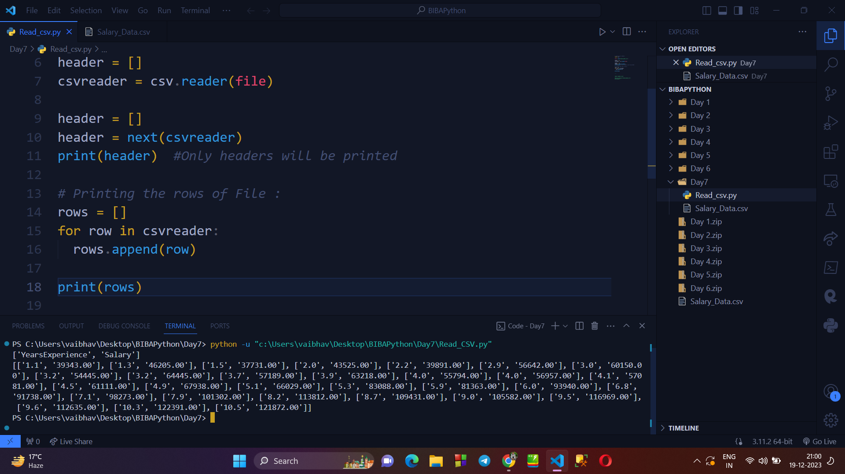

**→ Writing program to read a CSV File using WITH OPEN():**

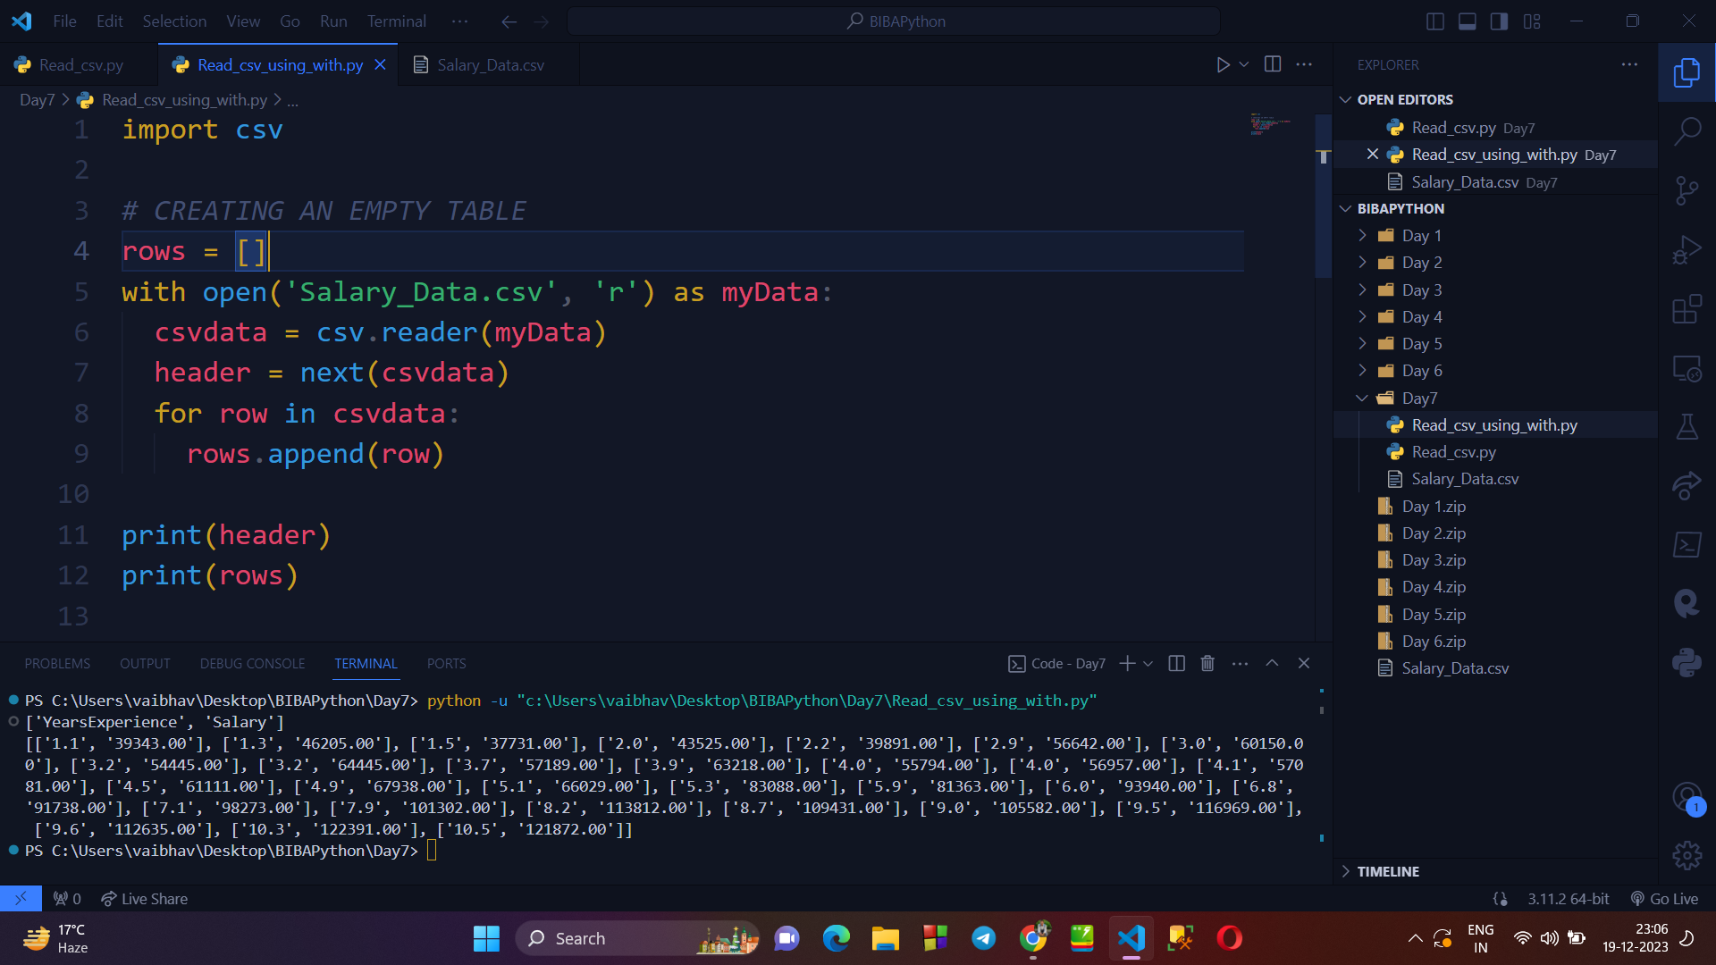

**→ Writing program to read csv file using readlines() :**

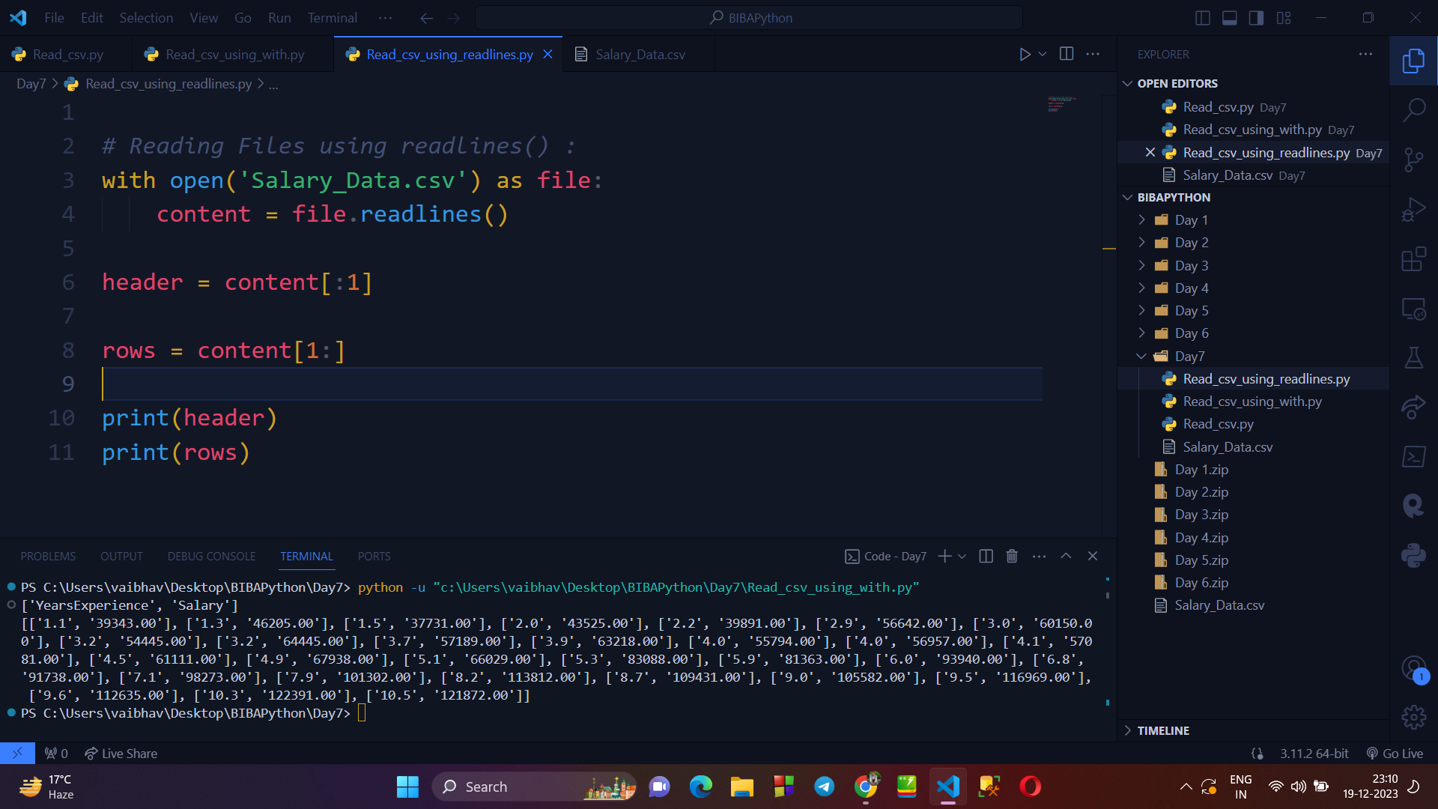

**→ Writing program to read data from the csv file using PANDAS library :**

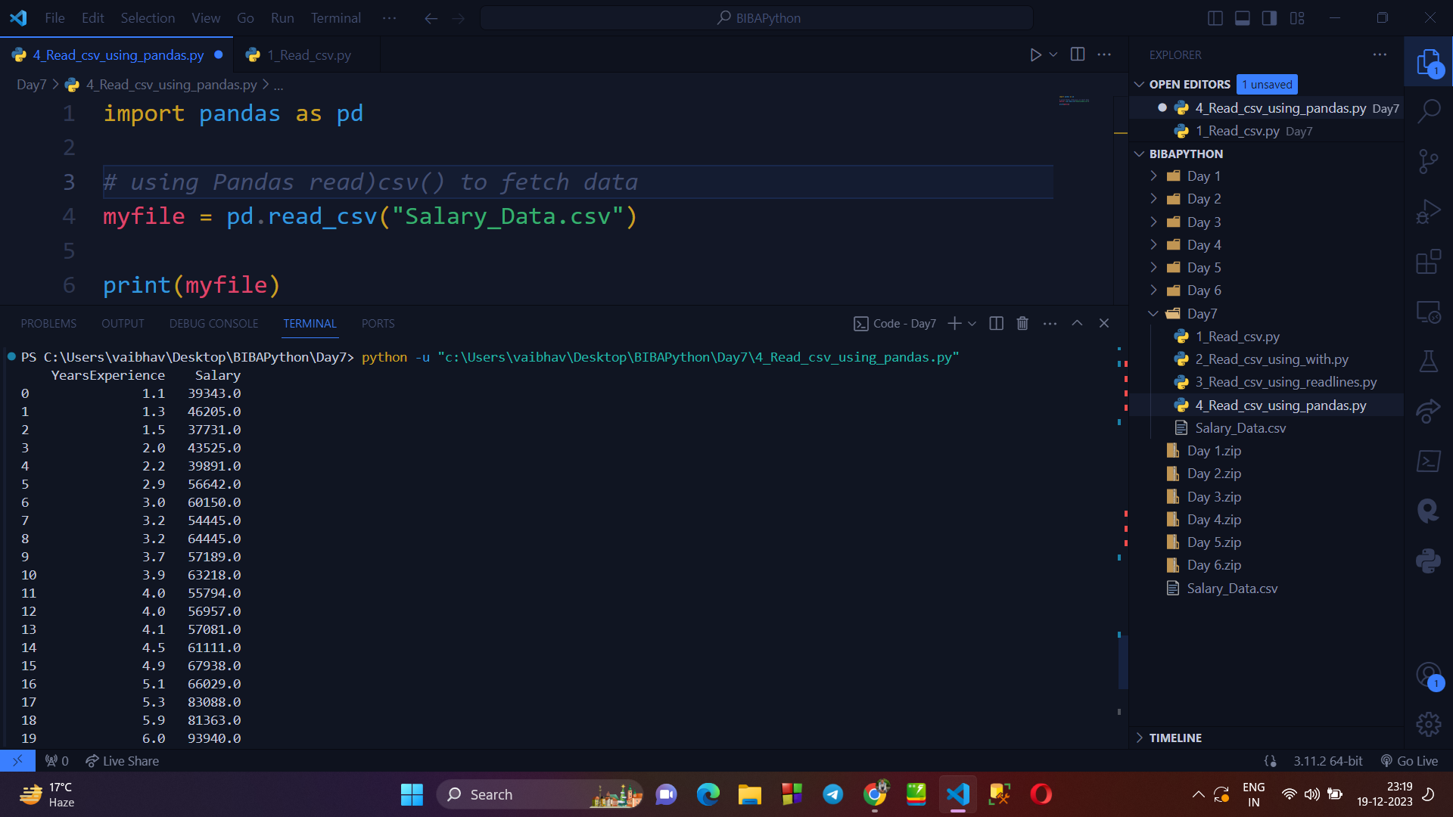

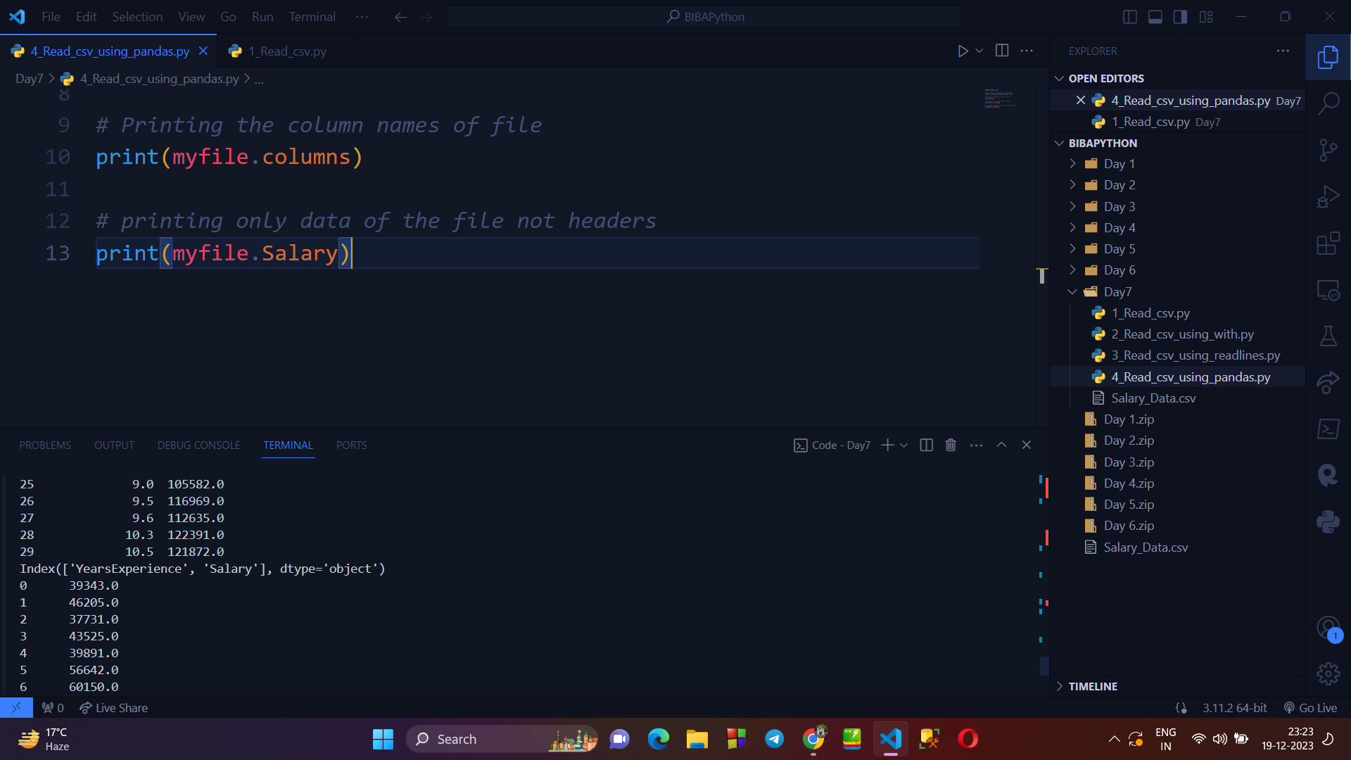

**→ Reading a CSV file using CSV.DictReader :**

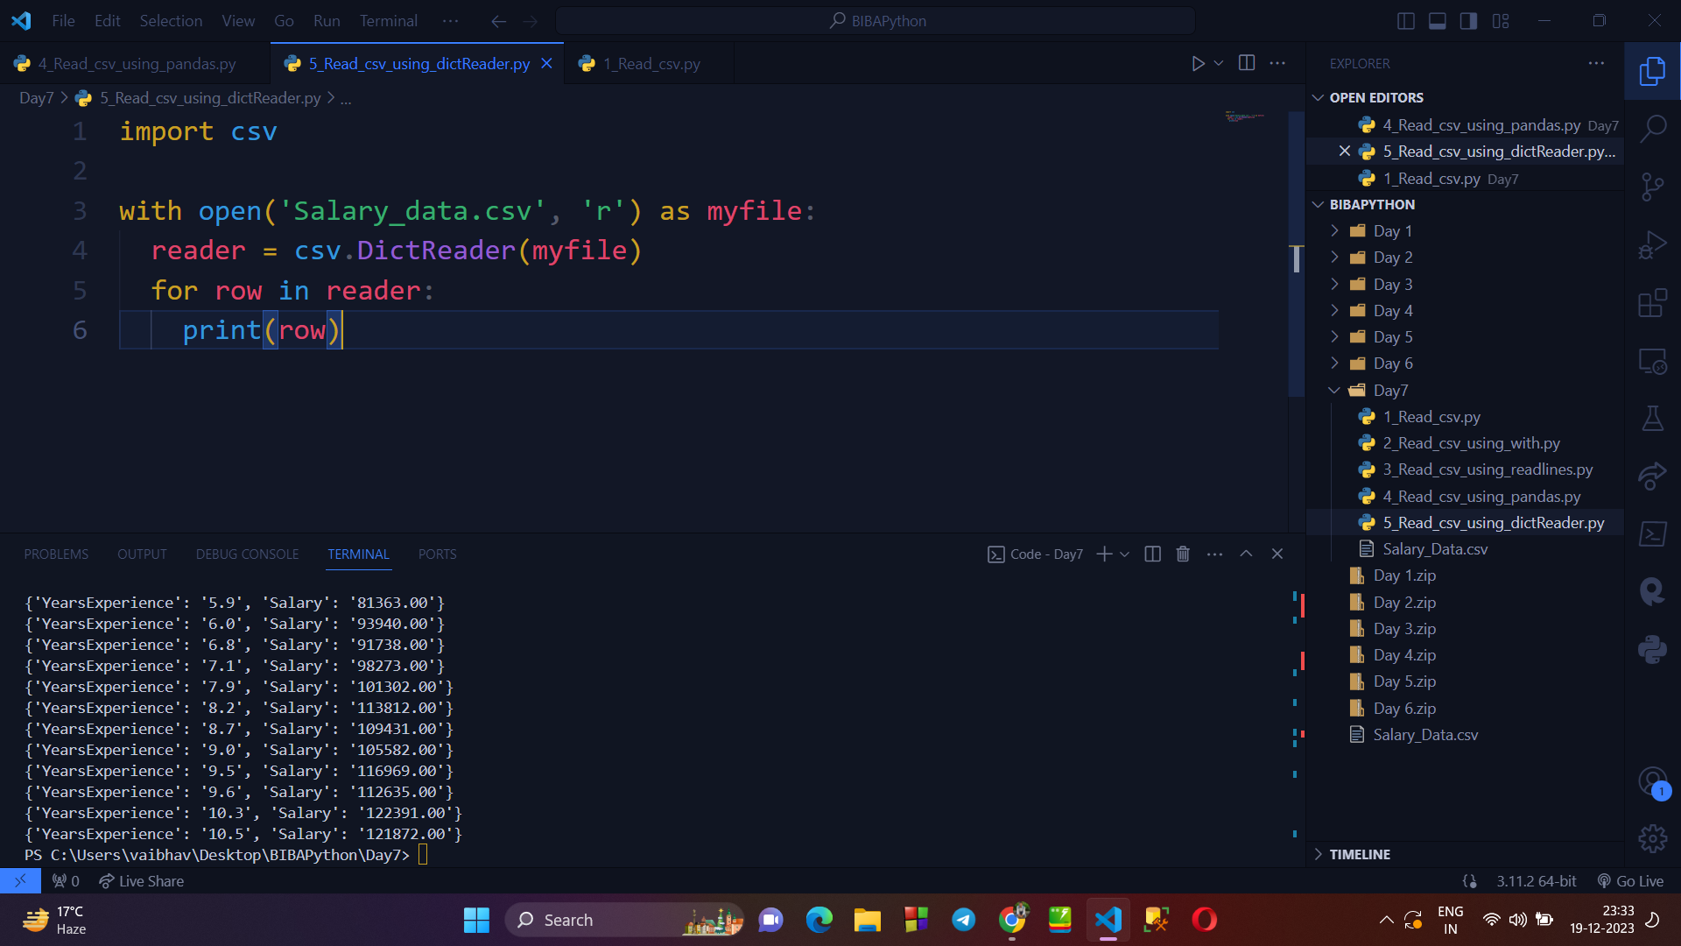

**WRITING IN CSV FILE :**

* As we used 4 methods to read the data of a csv file, similarly we can write data into file using following methods :
  + Write CSV file using csv.writer
  + Write CSV file using writelines() function
  + Write CSV file using Pandas
  + Write CSV file using csv.DictWriter

**→ Writing a CSV file using csv.writer() method :**

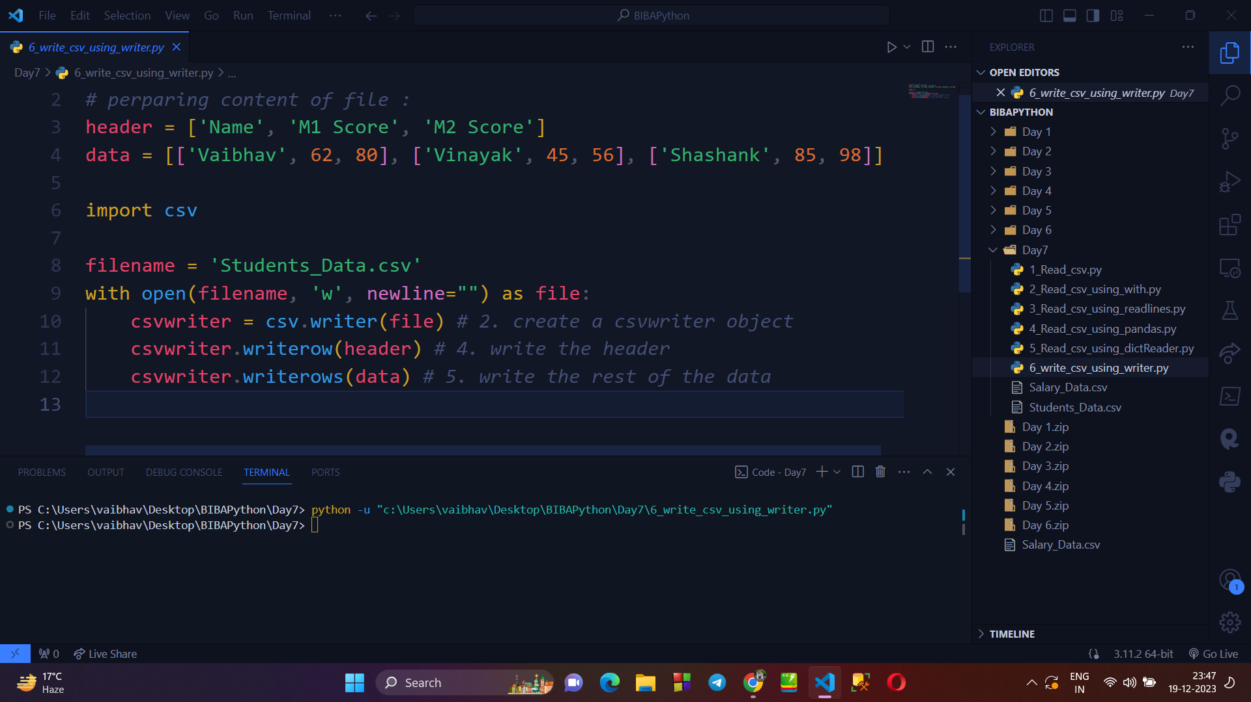

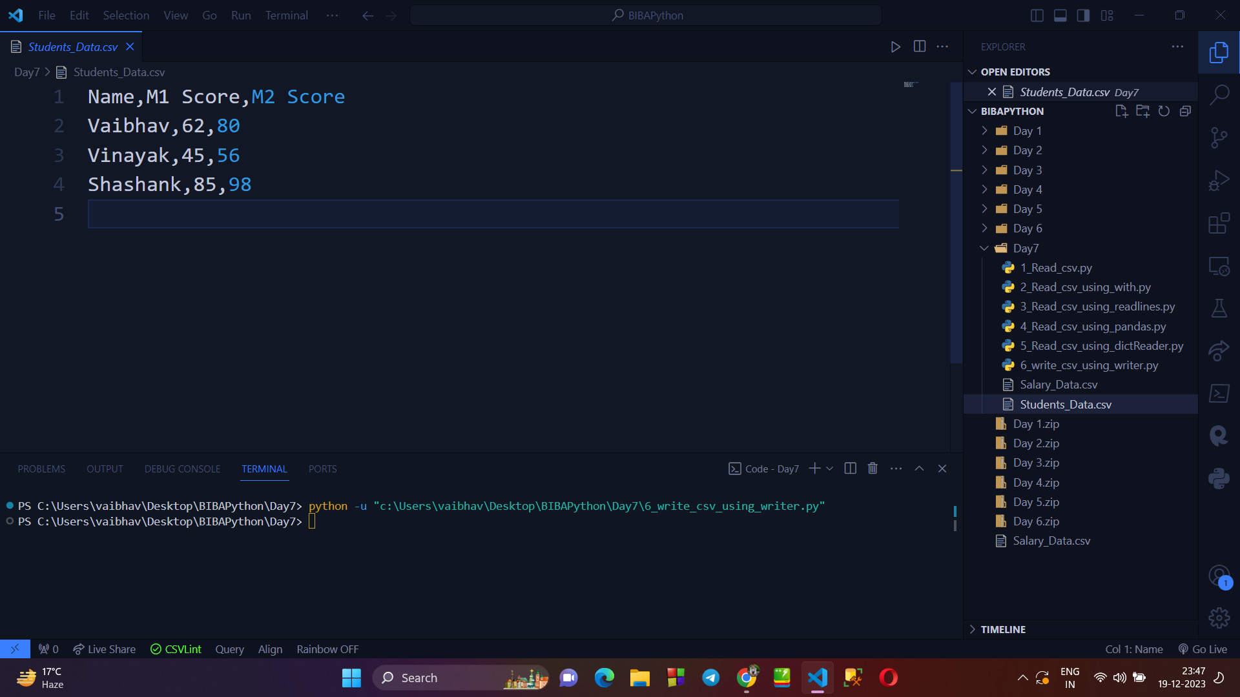

**→ Writing a csv file using .writeLines() :**

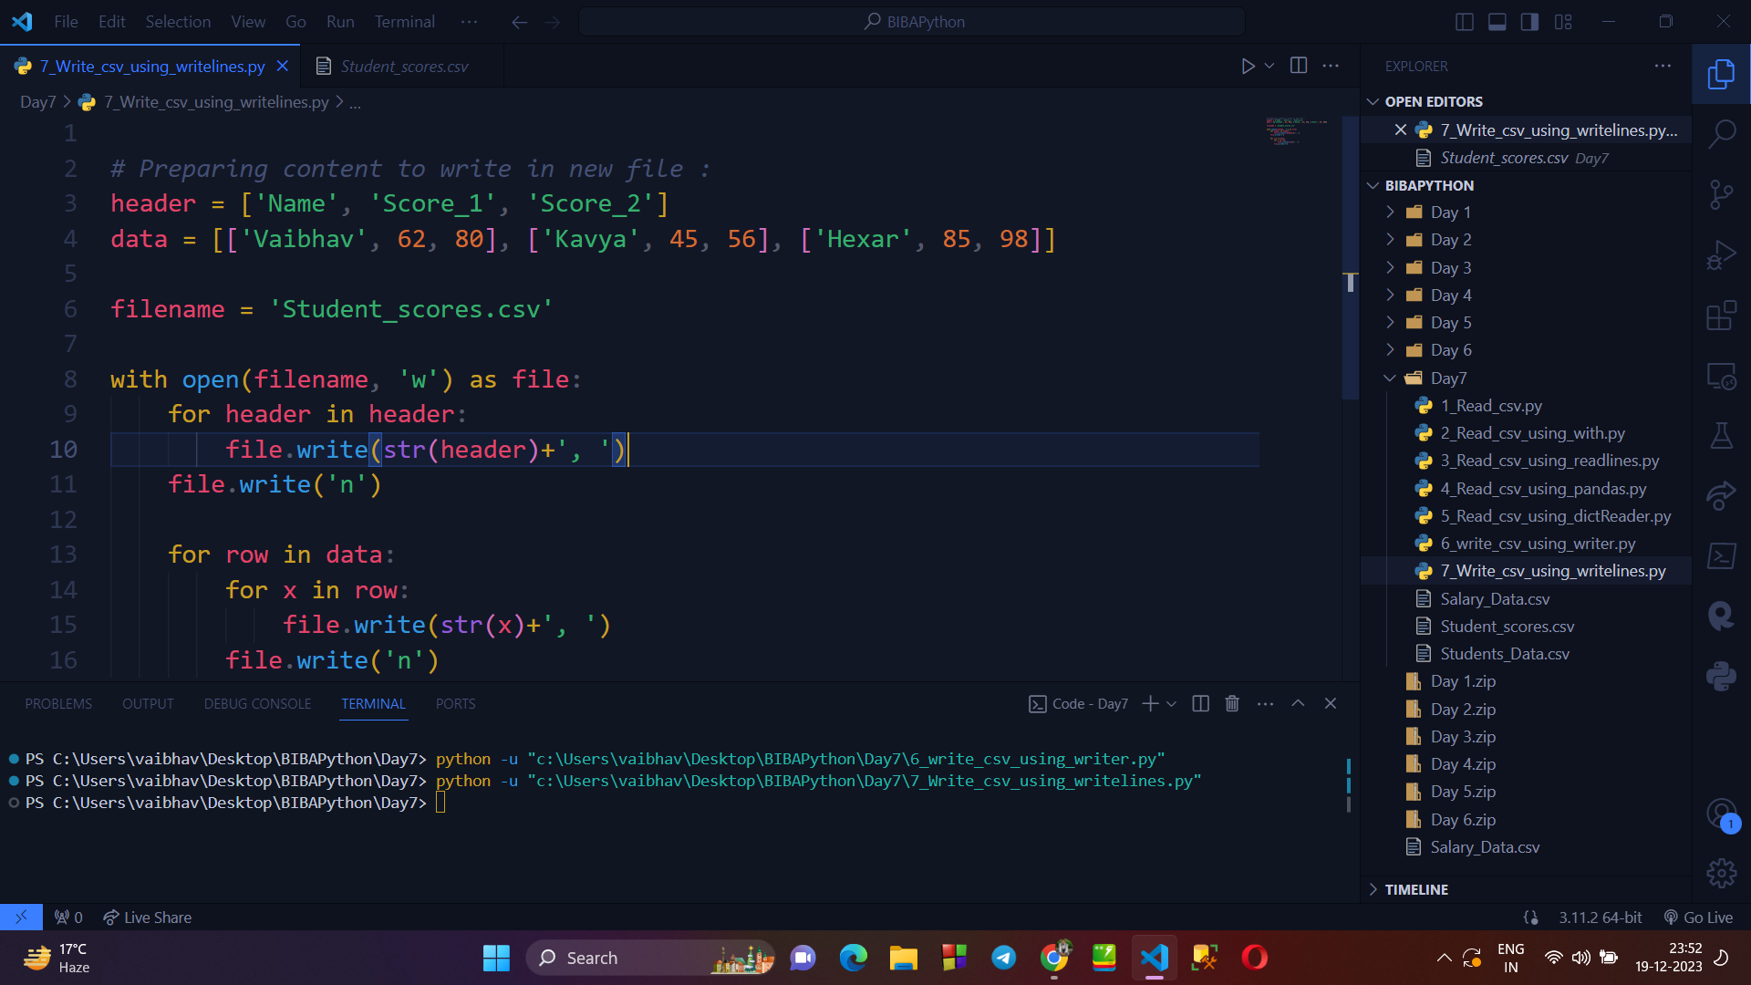

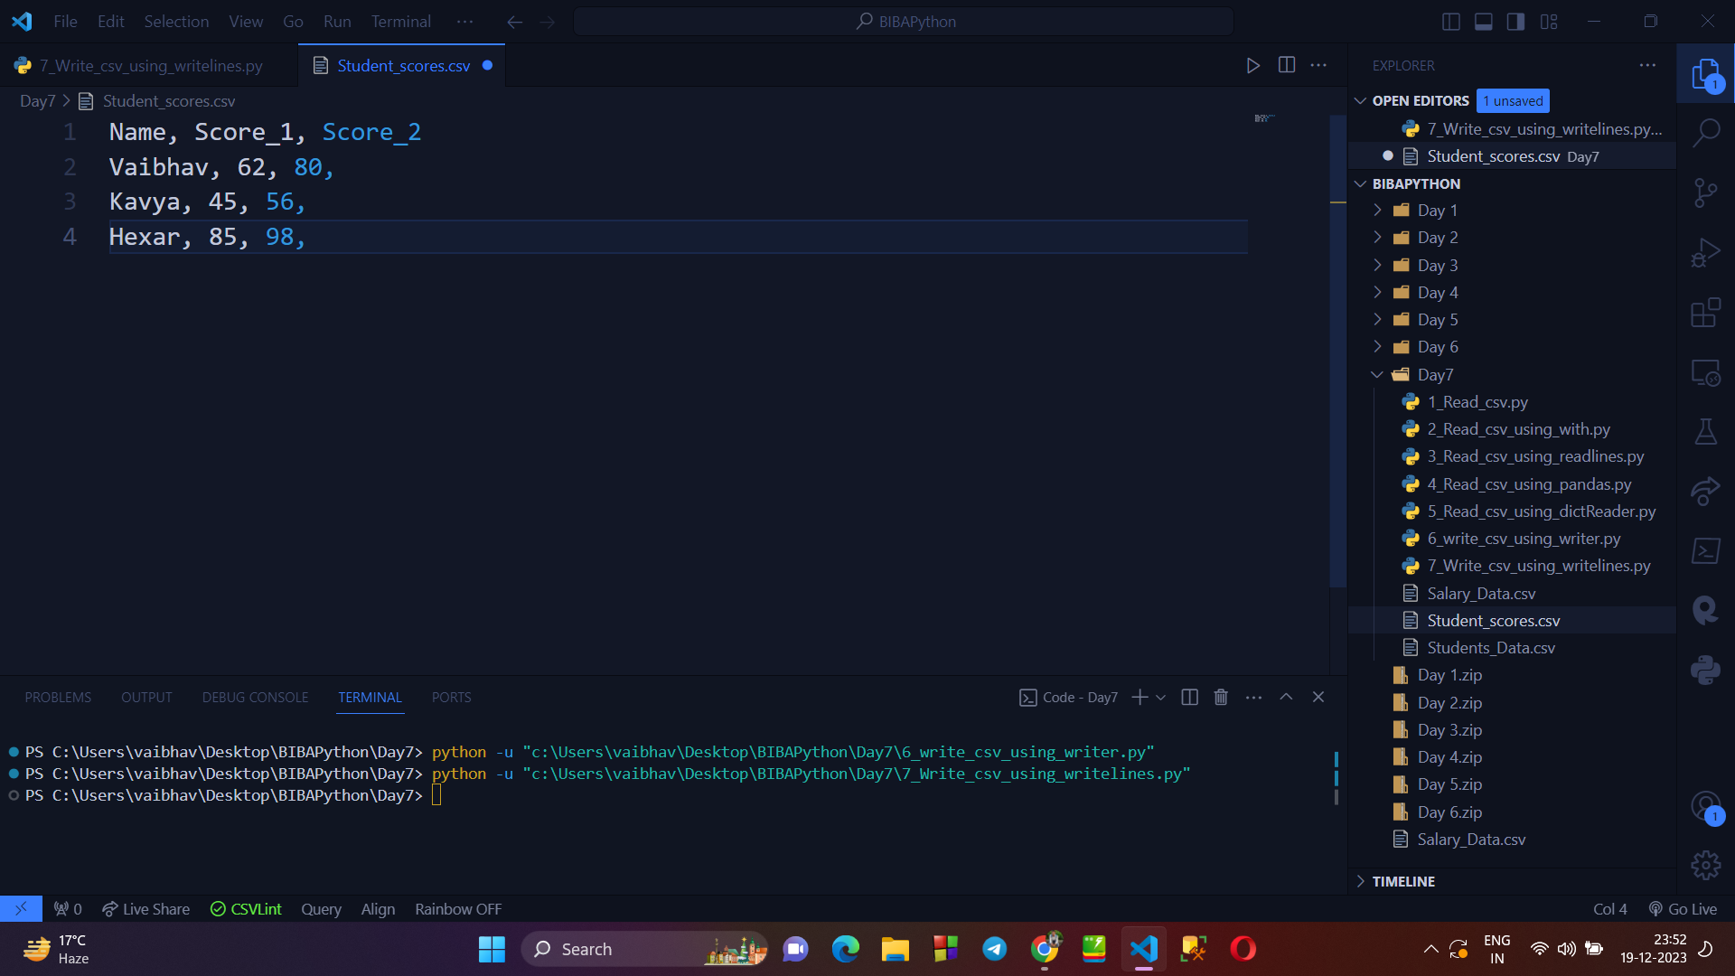

**→ Writing CSV file using Pandas library() :**

